Harvard Friends of the Arts
Present
Hanneke Cassell & Mike Block Duo
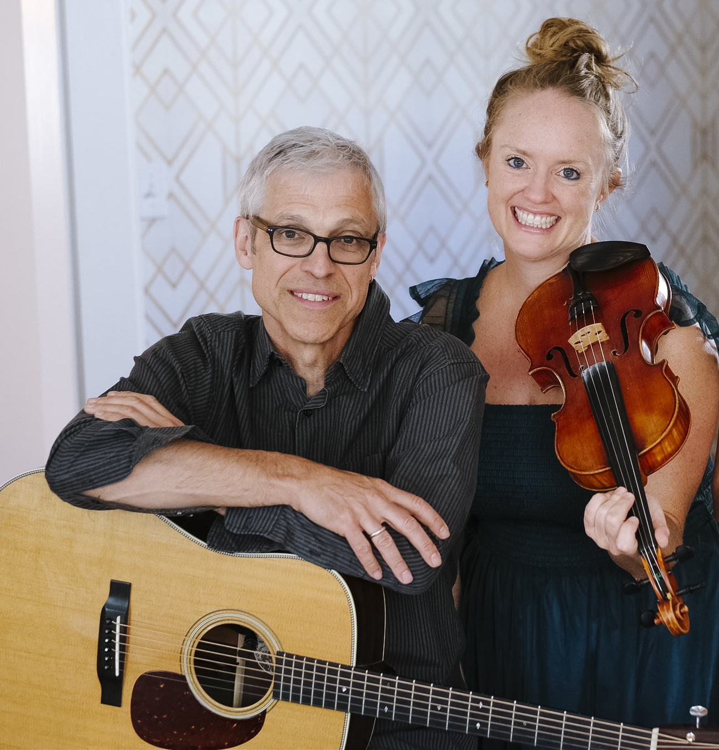
In Concert
Saturday, December 21
Harvard Public Library
Doors open at 7:00 PM
Show starts at 7:30 PM
Seating is limited. Please reserve seats:

Hanneke’s music is “exuberant and rhythmic, somehow wild and innocent, delivered with captivating melodic clarity and an irresistible playfulness.” ~Boston Globe

Free admission. Donations are appreciated. Further information: www.harvardpubliclibrary.org & www.hannekecassel.com

